1. **Tree Classification of AF, FA, LT, and CI (Circles) data according to PD = groups of personal drivers**

> setwd("C:\\Users\\baron\\Documents\\PKG\\PKG data")

> C = read.csv("AFFALTCI6segments.csv")

> library(tree)

> PKGtree = tree(PKG_Lifestyle ~ PDcomfort+PDmyself+PDpractical+PDsafe+PDunique+PDstd, C)

> plot(PKGtree,type="uniform")

> text(PKGtree)

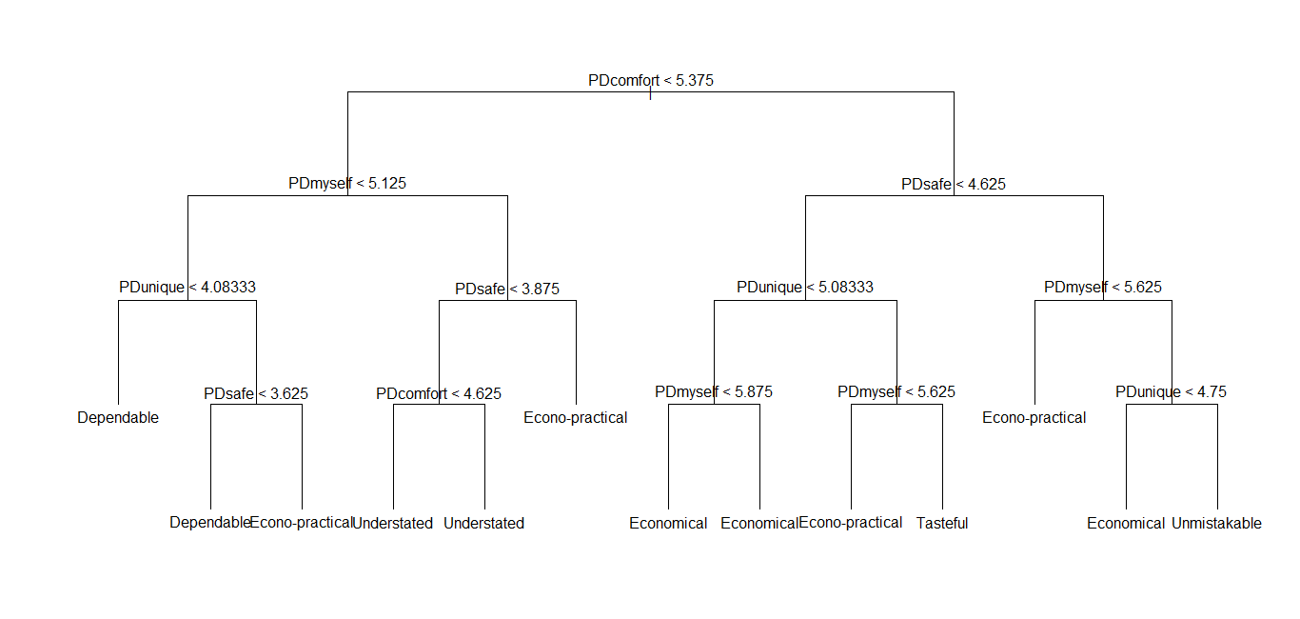

> summary(PKGtree)

Classification tree:

tree(formula = PKG_Lifestyle ~ PDcomfort + PDmyself + PDpractical + PDsafe + PDunique + PDstd, data = C)

Variables actually used in tree construction:

[1] "PDcomfort" "PDmyself" "PDunique" "PDsafe" **(Notice: PDpractical and PDstd are not used in the first 31 nodes!)**

Number of terminal nodes: 13

Residual mean deviance: 1.741 = 5662 / 3251

Misclassification error rate: 0.3199 = 1044 / 3264 **(Notice: The tree classification is less accurate than our K-means. It classifies only 68% correctly)**

1. **Tree Classification according to 22 personal drivers**

> PKGtree22pd = tree(PKG_Lifestyle ~ pdAre_practical+pdAre_me+pdServe_a_purpose+pdPerform_as_intended+pdMake_an_impact+pdAre_unique+pdAre_made_to_precise_specificat+pdReflect_craftsmanship+pdMake_me_happy+pdAre_economical+pdHave_balance__proportion+pdHave_a_recognized_brand+pdAvoid_controversy+pdMake_me_feel_good+pdAre_in_demand+pdShow_good_taste+pdDon_t_make_me_self_conscious+pdMake_me_feel_pride_of_ownershi+pdWon_t_cause_me_discomfort+pdSuit_my_personality+pdAre_distinctive+pdDon_t_attract_attention,C)

> plot(PKGtree22pd,type="uniform")

> text(PKGtree22pd)

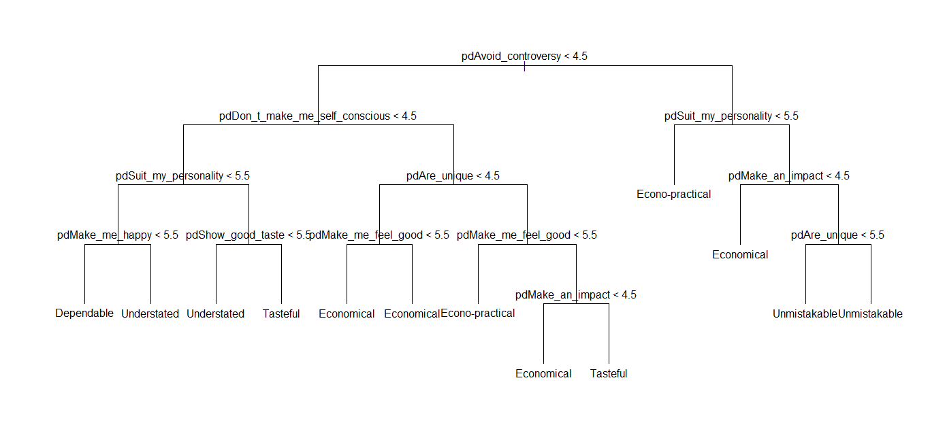

> summary(PKGtree22pd)

Classification tree:

Variables actually used in tree construction:

[1] "pdAvoid_controversy" "pdDon_t_make_me_self_conscious" "pdSuit_my_personality" "pdMake_me_happy"

[5] "pdShow_good_taste" "pdAre_unique" "pdMake_me_feel_good" "pdMake_an_impact"

Number of terminal nodes: 13

Residual mean deviance: 2.055 = 6680 / 3251

Misclassification error rate: 0.3781 = 1234 / 3264